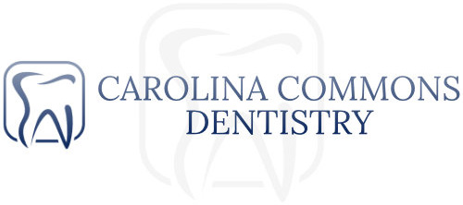

Extraction Consent Form:

Tooth Number(s):_______________

Extraction(s) are to be performed on the tooth/teeth listed above. While we expect no complications, there are some risks involved with this procedure.
The most common complications are as listed: Pain, infection, swelling, bruising, and discoloration. Adjacent teeth may be chipped or damaged during the extraction.
Nerves that run near the area of the extraction may be bruised or damaged. You may experience some temporary numbness and tingling of the lip and chin, or in rare cases, the tongue. In some extremely rare instances, the lack of sensation could be permanent.
In the upper arch, sinus complications can occur due to the roots extending near or into the sinuses. After the extraction, a hole may be present between the sinus and the mouth. If this happens, you will be informed and the area repaired.

By signing below you acknowledge that you understand the information presented, have had all of your questions answered satisfactorily, and give consent to perform this procedure.

_________________________________________ ______________
Signature Date

