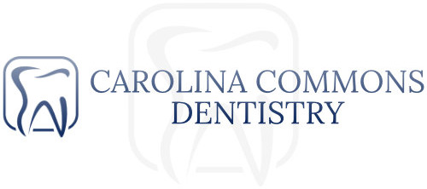
WRITTEN FINANCIAL POLICY
Thank you for choosing Carolina Commons Dentistry. Our primary mission is to deliver the best and most comprehensive dental care available. An important part of the mission is making the cost of optimal care as easy and manageable for our patients as possible by offering payment options.
You can choose from:
- Cash, Visa, MasterCard, Amex or Discover Card
- Care Credit- which offers convenient monthly payment plans. Care Credit does not have annual fees or pre-payment penalties and allows you to pay over time. This is subject to credit approval.
Please Note:
- Carolina Commons Dentistry requires payment prior to the beginning of your treatment. If you have insurance, we file a claim for you but please bear in mind, insurance is not a guarantee of payment. You are solely responsible for account, its balance and payment of balance. If your insurance company fails to pay us or denies the claim for any reason, any remaining balance for the account becomes immediately due and payable by you, as the patient and/or legal guardian. As a courtesy, we will attempt to collect payment from your insurance three times. We are NOT responsible negotiation of disputed claims. We are also not responsible for knowing your maximum spending amount and/or remaining spending amounts. We strongly recommend contacting your insurance company prior to any basic or major service to get your benefit information. It is very important to know your coverage! By initialing below, you as a patient and/or legal guardian of the patient are giving us authorization to release Protected Health Information (PHI) to insurance companies for reimbursement. (Patient/Guardian Initials) _______________
- For plans requiring multiple appointments, alternative payment arrangements may be provided. For larger, more comprehensive treatment plans of $1000 or more, a 25% deposit is required to secure your initial appointment. (Patient/Guardian initials) ________________
- In the event your account becomes more than 90 days past due, it will be referred to our collection department to ensure account performance and will accrue interest at the maximum allowable legal rate. All accounts that are turned over to our collections department will be reported to the three main credit bureaus. You will be responsible for all fees associated with the collection activities, attorney’s fees and court costs. (Patient/Guardian initials) _________________
- I understand that rude behavior, unruly activity, sexual harassment and profanity will not be tolerated. These actions will be grounds for immediate dismissal from this practice. (Patient/Guardian initials) _________________
- I understand that I will only be allowed in areas of the office that have been approved by the Carolina Commons Dentistry Staff. Failure to comply will be grounds for immediate dismissal from this practice. (Patient/Guardian initials)______________
Cancellation Policy
We consider the time set aside for your appointment to be yours alone. For this reason, we never double book our schedule or accept drop-ins, except in true emergencies. Consequently, when you cancel your appointment, especially at the last minute, our entire practice is affected. We understand that cancellations are sometimes necessary but we all pay the price for last minute cancellations. Plus, when you routinely miss appointments, your dental health suffers as well. Please pay us the same respect by giving us enough advance notice when you cancel an appointment so that we can use that time for the benefit of our other patients. A fee of $50 is charged for patients who Cancel or NoShow without 48 hour notice. (Patient/Guardian initials)__________________

If you have any questions, please do not hesitate to ask. We are here to help you get the dentistry you want and need.

Patient/Guardian Signature______________________________________________Date _____________________________
Patient Name (please print) ______________________________________________________________________________

